Давайте сделаем кроссворд.
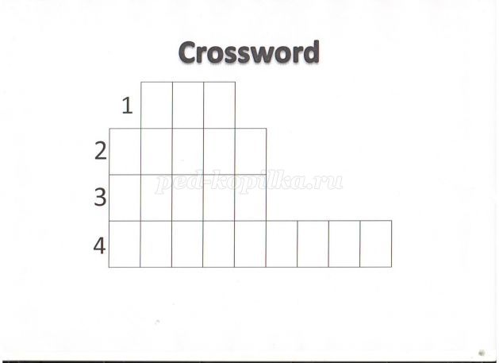
- I'm red and I have got a fine tail, I live in the forest, I like meat. (
2. It looks like a big cat. It has got stripes and a long tail. It lives in India and it can run very fast. ()
3. My long thin legs are good and fast, I like to gallop and to run. I think it is great fun. (horse)
4. I'm very big and I am grey, I live in the jungle, but you can find me at the zoo or in the circus. I don't like meat, I like vegetables, fruit and grass.

Давайте разгадаем этот ребус! Look at the blackboard. Guess the word.
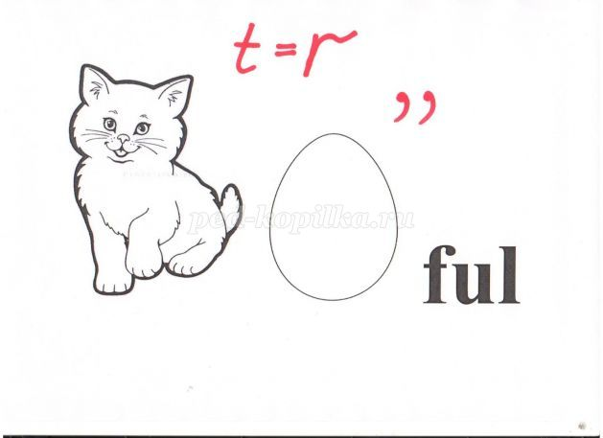
Все сделанные упражнения сканировать или фото прислать на электронный адрес
Селедцова Н.Н-эл.почта.seledcovanatalya@mail.ru

