26.05.2020 тема урока «итоговое повторение

. Кроссворд на тему LONDON
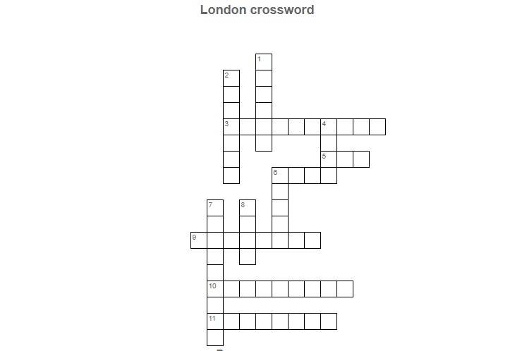
Across
3 Ceremonial guardians of the Tower of London.
5 British public service broadcaster with headquarters in Westminster, London.
6 Britain's national gallery of international modern art
9 A major international airport in London
10 The oldest tennis tournament in the world, which was first held in London in 1877
11 A theatre in St Martin's Lane, Westminster, built as one of London's largest and most luxurious 'family' variety theatres
Down
1 A river that flows through southern England including London.
2 A Stadium best known for hosting football matches, having hosted the FA Cup Final annually as well as numerous England International fixtures.
4 The nickname of London underground
6 Historic castle located on the north bank of the River Thames in central London founded in 1066
7 An area of South East London which is notable for giving its name to the Meridian (0° longitude)
8 It's the historic centre and the primary central business district (CBD) of London.

Все выполненные упражнения сканировать или фото прислать на электронный адрес.
Селедцова Н.Н.-эл.почта. seledcovanatalya@mail.ru

